The Impact of Customer-Centric Approach for Improving Customer Satisfaction of Retail SMEs

1Yoeun Youvanneath , 2Sar Vuthyrak , 3Thoeun Nimol , 4Pen Dalin

*Department of Digital Business, Cambodia Academy of Digital Technology   
Phnom Penh, Cambodia*

[1yovanneath.yoeun@student.cadt.edu.kh](mailto:1yovanneath.yoeun@student.cadt.edu.kh)

[2vuthyrak.sar@student.cadt.edu.kh](mailto:2vuthyrak.sar@student.cadt.edu.kh)

[3nimol.thoeun@student.cadt.edu.kh](mailto:3nimol.thoeun@student.cadt.edu.kh)

[4dalin.pen@student.cadt.edu.kh](mailto:4dalin.pen@student.cadt.edu.kh)

Abstract— Small and medium-sized firms (SMEs) frequently struggle to succeed in the highly competitive business landscape, experiencing issues relating to customer satisfaction, employee engagement, and market response. This is especially true in today's highly competitive retail industry. These difficulties may impede its expansion and long-term viability in a changing marketplace. This study explores the complex network of customer-centric retail business practices, such as employee centricity, consumer preference knowledge, and proactive customer feedback gathering and response. We discover that retailer guidance is greatly improved by customer feedback, which serves as a vital compass. Additionally, a customer-centric culture is fostered through staff empowerment and participation, which raises customer satisfaction. Retailers are able to offer audience-resonant solutions by using advanced analytics and data analysis to gain a deep understanding of their customers. Overall, this study provides actionable insights for companies looking to thrive in the fast-paced, customer-driven retail environment, highlighting the real advantages of giving customer-centric strategies priority.

Keywords— Customer-Centric Approach, Customer Feedback, Employee Centricity, Customer Understanding, Small and Medium Enterprise, Customer Satisfaction, Retail SMEs.

1. Introduction

Most businesses operate at one of two or three levels. Merely 9% of businesses function with a customer-centric approach, with manufacturers (5%) representing the lowest percentage and high-tech enterprises (19%) representing the highest percentage. These figures suggest that businesses have a compelling chance to set themselves apart by improving the way they interact with and satisfy their clients [1].

An example of One of the most well-known brands in the world, Amazon.com has been around for more than 20 years and has achieved unheard-of levels of success in the commercial world. Afterward, in 2011, well-known companies like Barnes & Noble and Borders filed for bankruptcy protection and are no longer in operation. Meanwhile, Amazon has expanded to include practically every imaginable category of goods, media, and services in addition to succeeding in their first business venture. According to some research, it made up almost half of all online retail as of 2018. This data that was taken from eMarketer also showed that at that time, Amazon was preparing to launch a physical store. Over the course of its last 26 years of business, Amazon has made an astounding transition from a bookseller to the world's largest eCommerce marketplace [2].

Even though Amazon.com was notably founded as a bookshop, Bezos insisted from the beginning that the website was more than just a place to buy goods for consumers. He was heard claiming on multiple occasions that Amazon.com was a tech corporation whose goal was to make consumer internet transactions easier. And because of this, the business will start selling items other than books. The research so that one of the main key metrics that led to the success of amazon.com is Customer Centricity [3].

1. Background

In today's highly competitive business landscape, achieving and maintaining high levels of customer satisfaction is paramount for the success and sustainability of organizations. Customer satisfaction not only influences customers' loyalty but also serves as a key indicator of overall business health. To this end, businesses continually seek strategies and practices that positively impact customer satisfaction [1].

An organizational approach, paradigm, and mindset known as "customer centricity" Centers the firm around the customer's needs rather than its offerings or revenue. When a company operates with a customer-centric culture, it views customer-centricity as something other than an afterthought or as the result of providing excellent customer service. They take a deliberate and strategic approach to customer experience, making the consumer the Center of attention from the outset. Every employee and procedure in a customer-centric business participates in the planning and execution of the customer experience, regardless of their direct contact with customers. Every employee is taught to concentrate on providing an outstanding customer experience in a customer-centric environment to foster repeat business and loyalty. Customer experience is more than just customer service, sales, marketing, etc., even though this is how most people conceive of it. When an organization adopts a true customer-centric strategy, all employees—even those who do not directly interact with consumers—perform their work with the customer's best interests in mind. Every employee at a company that prioritizes customer satisfaction understands and operates with the customer as the Center of attention. This is essential for long-term business success. The goal of policy direction and decision-making is always to prioritize providing excellent client experiences [4].

With the customer now in charge, companies need to change the way they communicate and build relationships with both existing and potential customers. Businesses that respect their relationships with customers are seeing a decline in attrition and an increase in client lifetime value. One way to accomplish this is by implementing a customer-centric strategy. You can start small, even though it takes time to grow into a truly customer-centric organization. Customer-centric business strategies focus on providing an excellent customer experience before and after the transaction to boost customer loyalty, stimulate repeat business, and foster business growth. However, a customer-focused company must do more than just offer top-notch customer support [5].

Prime examples of customer-centric firms that have spent years developing a culture around the requirements of the consumer are Amazon and Zappos. They genuinely care about providing value to their customers. Indeed, Zappos is content to let go of workers who don't align with their customer-focused culture [5].

1. Research Topic and Problem

In the context of the retail sector, this study topic focuses on examining the impact of customer-centric practices on consumer satisfaction. The objective of this study is to evaluate how employee centricity, a thorough understanding of customers, and customer feedback affect and elevate customer satisfaction levels. To ascertain the importance of these aspects in influencing the retail experience and raising consumer happiness, the study will employ empirical research and analysis. The retail sector is going through changes, as consumer behaviour, technology advancements and market dynamics evolve. In this changing landscape medium sized businesses, in retail face a challenge; how to adjust and succeed in a fiercely competitive market while also ensuring customer satisfaction remains high and continues to improve [6].

1. Research Objective

This study has several key objectives. First, it aims to investigate the impact of customer feedback on customer satisfaction in retail SMEs, examining the relationship between customer feedback collection and its influence on satisfaction levels. Second, it seeks to assess the effect of employee centricity on customer satisfaction, focusing on the impact of employee-centric cultures and engagement on customer satisfaction. Third, it aims to explore how customer understanding enhances customer satisfaction by analysing the role of profound customer comprehension in meeting customer preferences and needs. Furthermore, the study aims to provide actionable recommendations for enhancing customer-centric practices and understanding the specific challenges and opportunities faced by retail SMEs in implementing these strategies. Ultimately, the research strives to contribute to the existing knowledge by shedding light on how SMEs in the retail sector can leverage customer feedback, employee centricity, and customer understanding to elevate customer satisfaction and bolster their competitiveness in the marketplace.

1. literature review
   1. Customer Satisfaction

Customer satisfaction is a fundamental aspect of marketing, as it addresses the needs and desires of consumers. Zeithaml, Bitner, and Gremel (2006, p. 110) define satisfaction as the evaluation made by customers regarding whether a product or service has fulfilled their expectations and requirements. By understanding the expectations of customers, businesses can tailor their offerings to meet these needs and ultimately achieve customer satisfaction (Cant, 2013). Among the various models used to measure customer satisfaction, the American Customer Satisfaction Index (ACSI) is the most widely utilized [7].

Because satisfied customers have a big impact on a business's profits, customer satisfaction has emerged as the most important factor in the business world. (2001:6) Kotler the degree to which a product's perceived performance meets a buyer's expectations is known as customer satisfaction. When a product doesn't meet expectations, the customer is not really pleased. Once performance meets or surpasses expectations, customers are more satisfied [8].

Satisfaction refers to the emotions a person experiences when comparing their perception and expectation, according to Kotler (2000). Buttle (2006) concurs that satisfaction is a pleasurable response to fulfillment, while dissatisfaction is the opposite. Wiele, Boselie, and Hesselink (2002) add that satisfaction is a positive behavior that results from evaluating all aspects of a working relationship with other parties. In the business context, maintaining positive relationships with customers can lead to several desirable outcomes, as noted by Kotler (2000) [9].

The results showed that there was a difference between the expectations and perceptions of the customers, with assurance, responsiveness, and reliability being the most important aspects impacting consumer satisfaction. To increase customer satisfaction and gain a competitive advantage, these outcomes highlight the necessity of continuously evaluating and improving the quality of services [10].

For companies of all sizes and in all industries, customer satisfaction is critical to their success. When clients are happy, they often grow devoted to the business and its products and services, and they could even start promoting the brand. Additionally, happy clients are less likely to look for different suppliers and are less sensitive to changes in price. As a result, they are less likely to move to rival companies. Additionally, happy consumers are more likely to spread the word about the business and its offerings, which enhances its growth and reputation [11].

* 1. Customer Centricity

In recent years, the notion of customer-centricity has garnered considerable attention. It pertains to a fundamental outlook and principles that prioritize customer relationships above all else within a company. This methodology surpasses the mere provision of satisfactory customer service; it entails comprehending the requirements and anticipations of customers and subsequently devising products, services, and encounters that fulfill or surpass those expectations [12].

Customer-centricity is a strategic approach in business that places utmost importance on meeting the needs and expectations of customers. This entails gaining a deep understanding of individual customers and providing them with precisely what they desire. Companies that adopt a customer-centric approach tend to be more profitable compared to those that do not prioritize the market. Additionally, they enjoy higher levels of customer satisfaction and loyalty. Still, there might be some disadvantages to changing the organizational structure to prioritize the needs of the customer, like higher coordination expenses. Customer-centricity is still a useful strategy that can help businesses achieve several important goals despite these possible obstacles, especially in the dynamic and constantly shifting business environment of today [13].

Customer centricity, a widely discussed business concept in recent years, lacks a universally accepted definition and is often employed in various contexts. It can be perceived as a concept, mission statement, process, marketing and sales strategy, or corporate strategy. Despite the absence of a precise definition, customer centricity is commonly understood as the practice of prioritizing the customer in all business decisions. This entails comprehending customer requirements and expectations, and subsequently developing products, services, and experiences that not only meet but also surpass those expectations [14].

Customer centricity revolves around comprehending and fulfilling the demands of customers, as highlighted in Box 1.1 From a business standpoint, this implies that enhancing value for customers is advantageous as it enhances product utilization, contentment, and loyalty, while simultaneously reducing expenses. Studies conducted in a developed market context have revealed that a mere 2 percent rise in customer retention results in a substantial 10 percent reduction in costs (Murphy and Murphy 2002). Additionally, other research has demonstrated that a mere 1 percent increase in customer satisfaction leads to a noteworthy 2.37 percent increase in return on investment (ROI), whereas a 1 percent decrease in satisfaction results in a significant 5.08 percent decrease in ROI (Gupta and Zeithaml 2006) [15].

 Customer-centric businesses prioritize the creation of tailored solutions, identifying needs, and opportunities, and allocating resources to cater to individual customers. Within organizations, numerous factors contribute to the smooth functioning of operations, with customers being the pivotal element in this chain of processes. Consequently, companies should adopt the customer-centricity model as the optimal approach. This model encompasses all stakeholders and actors involved, ensuring that not only customers benefit, but also enabling the company to gain a competitive advantage over rivals and competitors [16].

* 1. The Positive Impact of Customer Feedback

Feedback from customers is essential for understanding their needs and preferences, particularly when a business introduces new items [17]. Customer feedback techniques include focus groups, in-person research, and customer phone polls to find out what qualities, flavours, or fashions consumers are most interested in [17]. There are two types of customer feedback: requested and unsolicited. The company encourages solicited feedback by using methods like focus groups and questionnaires that ask customers for their opinions. Unsolicited customer feedback, on the other hand, is dependent on the consumer's own willingness and desire to share their experiences [18]. The customer feedback has a positive impact on front-line employee outcome, company outcome, and society outcome [19]. Customer feedback including complaining, complement that is typically divided into two positive feedback and negative feedback. It has been discovered that one of the main ways to speak with customers directly is through complaints. Customers who have complaints are still communicating with us, which gives us the chance to make them happy again so they will come back to buy from us [20]. On the other hand, reviews from customers give businesses insightful information about their goods and services. Businesses can learn what customers like and hate about their goods by examining reviews. By incorporating this feedback, the product or service can be improved, improving the user experience and raising customer satisfaction [21].

* 1. The Positive Impact of Employee-Centric

CRM (customer relationship management) puts the customer first, emphasizing customer-centric context that is putting customers at the Center of the business's marketing endeavours and concentrating on customers rather than sales. Employees of the organization need to be customer-focused [22]. It would be an understatement to say that employee centricity comes before customer centricity. Customer and employee experiences are equally vital. It is no longer possible to view employee-centricity as a silly concept given its positive effects [23]. According to a University of Missouri study, businesses that successfully address employee satisfaction can significantly raise employee morale, reduce employee turnover, and improve customer satisfaction and repurchase intention. According to research by Profiles International, "the anti-customer-centric culture," or employee disengagement, alone is responsible for a staggering $350 billion in lost revenue [24].

Fig 1. Employee centricity causal model

A frontline employee's appropriate attitude has a positive impact on the level of customer satisfaction, and their appropriate attitude also has a greater positive impact on customer engagement during service failures than it does during initial satisfaction [25].

* 1. The Positive Impact of Understanding Customer

There are many things that we need to understand about customers, but customer experience is one to hold customers come and buy again [26]. In a recent study conducted by Accenture (2015) in collaboration with Forrester, executives were asked about their top priorities for the upcoming year, and improving the customer experience consistently received the highest ranking. Customer experience includes all facets of a business's offering, including, of course, the level of customer service as well as advertising, packaging, features of products and services, security, and ease of use [27].Electronic communications and transactions (ECT) state that before making a purchase, customers usually gather and evaluate product information from friends or the media. They then create their own expectations. So, customer satisfaction is influenced by positive customer experience [28].

1. Methodology
   1. Research Framework

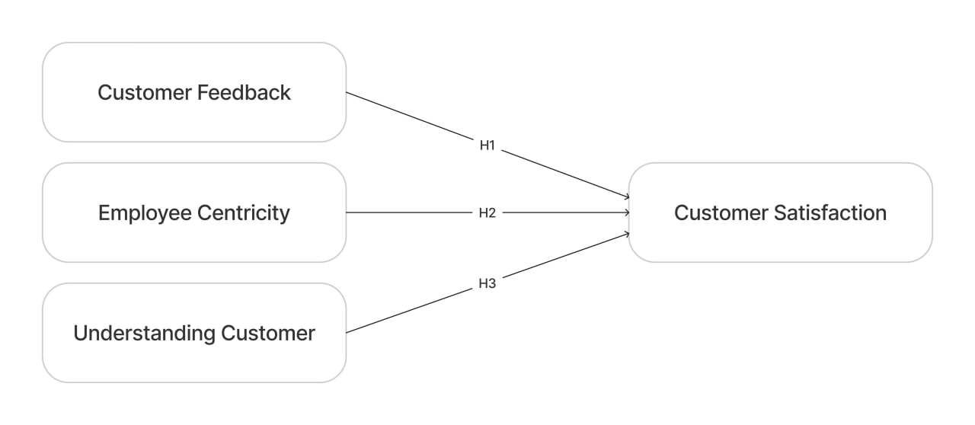

Fig. 2 Research Framework

* 1. Research Agenda

The approach for measuring customer satisfaction is covered in the research agenda. To locate books, papers, and articles about the research agenda, we use the following search key: "measure/develop customer satisfaction," "measurements of customer satisfaction, “Employee Centric," "Customer Feedback", "Understand Customer needs, "and "Customer satisfaction" are the metrics used to measure scale, index, or proxy. Determining the most often used approaches is the primary goal of the study.

* 1. Literature Search Criteria

The search will include peer-reviewed journal articles, books, government publications, conference proceedings, and other pertinent material to find pertinent articles. First, we used specific keywords, a thorough search is done through academic dataes, trade journals, and reliable websites to find case studies that examine how employee centricity, customer comprehension, and customer feedback affect customer happiness. To broaden the scope of the literature search, a Google Scholar search for other papers containing the same search terms will be carried out online.

* 1. Literature Search Procedure

After preliminary searches, 51 articles in all from a variety of sources, including books, professional and scholarly journals, and other publications, were located. The relevance of the approach would then be determined by analysing the content of these publications. The articles' goals, methods, and conclusions would be examined in greater detail if it was determined that they were pertinent to the study's agenda. The papers that are most valuable to the research topic were obtained by applying the citation criterion. All publications published more than two years ago that earned less than two citations were removed, except for extremely recent books and articles. Following the investigation, 28 pertinent articles were selected.

* 1. Statistical Analysis of Selected Articles

The literature searches conducted across many sources yielded 28 articles with information that was significantly connected to the question of how the integration of customer feedback, an employee-centric culture, and a deep understanding of customer needs collectively impact overall customer satisfaction. the coverage of the chosen articles can be categorized.

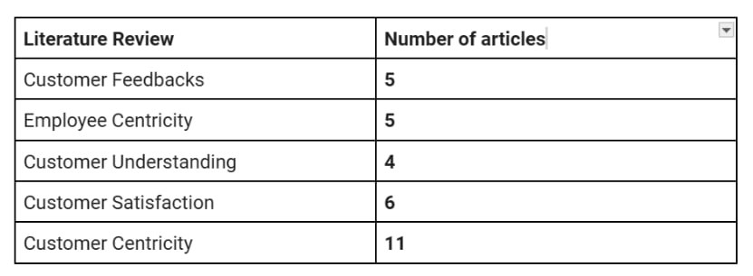

Fig 3. Number of articles for each Literature Review.

The chosen articles are from over 13 periodicals that span a broad spectrum. The Journal of Management, The Journal of Technology and Applied Sciences, The Journal of Hospitality Management, International Journal of Scientific Research in Engineering and Management are the journals that have the highest volume of chosen articles about measuring CS.

Every other article met the citation criteria with a minimum of two citations. The number of articles for each period of citation from the articles is displayed in.

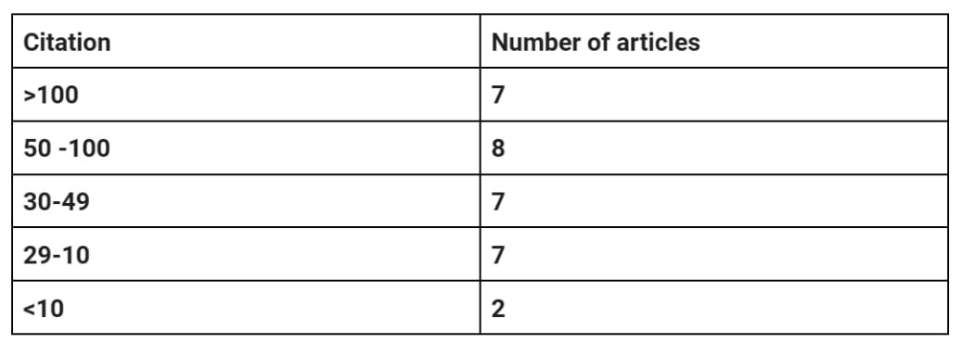

Fig 4. Number of articles for each interval of citation.

1. Result

According to the available information, a sizable portion of people (38%) seem to think that customer reviews are crucial when making a purchase decision. A significant portion of people (29%) think that reviews are important. A significantly smaller percentage of respondents—14%—thought that customer reviews were somewhat essential, but just 14% thought that they were moderately important. A mere 5% of respondents said that customer reviews had no bearing whatsoever. According to the available information, a sizable portion of people (38%) seem to think that customer reviews are crucial when making a purchase decision [29].

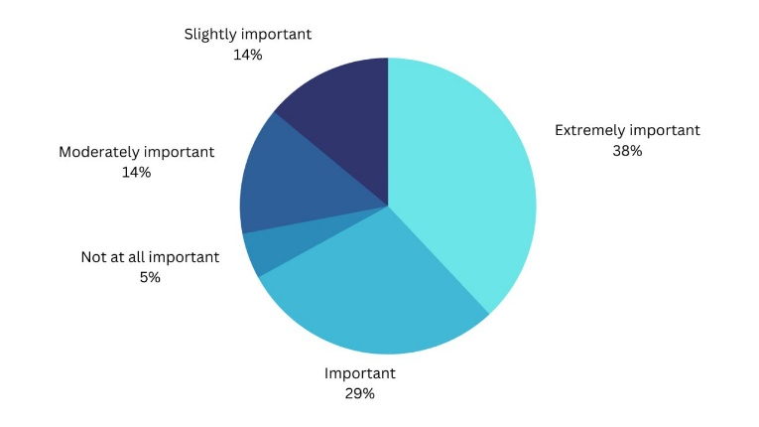

Fig 4. How important are customer reviews to you when making a buying decision?

The case study was collecting data through surveys with well conducted questionnaires which received 307 responses with 160 of these being obtained through the online survey. Participants will rate their perceptions of service quality dimensions (responsiveness, reliability, assurance, empathy, and tangibles) using a Likert scale. The scale will assess their agreement or disagreement with statements related to each dimension. It shown how satisfied customer through employee [30].

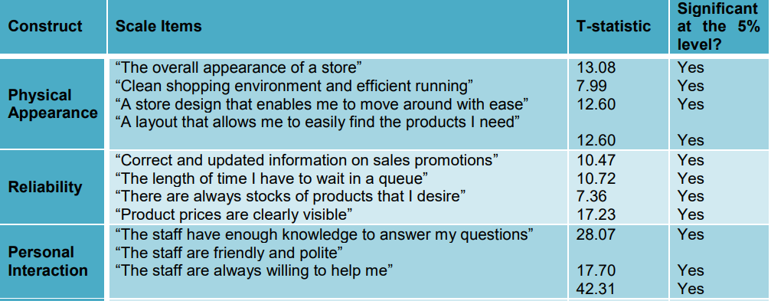

Fig 5. Item Reliability Analysis Results

Effective customer satisfaction hinges on cultivating a customer-focused culture within the organization. Key strategies involve total organizational commitment to customer care, continuous staff training, integrating customer focus into individual objectives, empowering frontline personnel to make customer-centric decisions, and fostering a culture of continuous improvement [31].

1. Discussion and Suggestion
   1. Discussion

A customer-centric approach has become a crucial factor in determining customer satisfaction in the retail industry. Our study has clarified this approach's complicated nature, which includes employee centricity, an extensive knowledge of customer preferences, and customer feedback. Our findings indicate that customer feedback is certainly a crucial component of the customer-centric equation. Retailers that continually seek out and respond to customer feedback are better able to match the needs of their customers with their goods and services, which increases customer satisfaction significantly. Our findings support the claim that consumer feedback guides retailers toward more customer-focused strategies by serving as an indicator for decision-making.

Additionally, our research emphasizes how important employee centricity is in developing a culture which is customer centric. Overall customer satisfaction is greatly increased by employees who are empowered, driven, and engaged to put the needs and experiences of their customers first. Because there is a direct correlation between employee and customer satisfaction, retailers must support initiatives that give their employees training, empowerment, and recognition. Our research has demonstrated that there is a beneficial relationship between employee and customer satisfaction, which can serve as a foundation for retailers looking to gain an advantage in the marketplace.

Another important finding of this research is how important it is to have a deep understanding of the customer. Retailers are better able to customize their goods and services to each customer's unique preferences and behaviors when they invest in collecting, evaluating, and using customer data. The study clearly demonstrates that advanced analytics and customer segmentation techniques, when combined with data-driven decision-making, can be a powerful tool for improving the customer experience. By gaining a deeper understanding of their customers, retailers can provide tailored solutions that appeal to their intended market.

Our study adds to a better understanding of how a customer-centric strategy affects customer satisfaction in the retail industry. Retailers that place a high priority on employee engagement, customer understanding, and customer feedback appear to have happier customers. This enhances a retailer's reputation and competitive position in the market in addition to increasing customer loyalty and repeat business. It also amplifies positive word-of-mouth recommendations. The results demonstrate that a customer-centric strategy is a workable means of attaining higher customer satisfaction and, eventually, a profitable company.

* 1. Suggestions for Future Research

There are several interesting possibilities for further study in this area in the future. First, to further our understanding of this idea, it would be helpful to investigate the tactics and resources that retailers employ to put a customer-centric approach into practice. Examining the most effective procedures and best practices for getting employee feedback, using customer data, and gathering customer feedback may provide insightful information for the retail sector.

Moreover, conducting comparative analyses among diverse retail subsectors may provide a more advanced comprehension of the efficacy of a customer-centric approach. To shed light on industry-specific dynamics, research could, for instance, look at the differences in impact between grocery retail, electronics retail, and fashion retail.

The long-term effects of a customer-centric approach on customer satisfaction and business performance may be better understood through a longitudinal analysis. Retailers and researchers alike would benefit from tracking changes over a few years and evaluating how consistent implementation affects customer loyalty and financial outcomes.

An exciting area for research is the introduction of customer-centric technologies into the retail space, such as chatbots, artificial intelligence, and personalized recommendation systems. A forward-looking viewpoint might be obtained by looking into how these technologies affect customer-centric strategies and how they affect customer satisfaction.

Ultimately, it makes sense to investigate how cultural and geographic variables affect how successful customer-centric strategy is. Certain customer-centric strategies may not be applicable in certain regions or cultures due to the significant variations in consumer expectations and behaviors. Retailers may be able to adjust their strategies for particular markets and demographics if they are aware of these variations.

1. Conclusions

Finally, our study emphasizes how important it is for the retail sector to adopt a customer-centric strategy. Active consumer input, a thorough grasp of client preferences, and employee centricity are all necessary. Retailers rely heavily on consumer feedback to improve customer satisfaction, which is a critical differentiator. Moreover, it is emphasized that a major factor influencing customer happiness is staff centricity. Employee and customer satisfaction are closely correlated when empowered and engaged staff put the needs of their customers first. Retailers can also use advanced analytics and segmentation to customize offerings to individual preferences by gaining a thorough understanding of their customers through data research.

In conclusion, a customer-centric approach is critical for long-term success in the cutthroat retail sector, providing useful information to companies striving for expansion and superiority.

References

|  |  |
| --- | --- |
| [1] | D. C. I. B. a. S. R. Jonathan Hughes, “What is Customer-Centricity, and Why Does It Matter?,” forbes, 26 September 2021. [Online]. Available: https://cmr.berkeley.edu/2021/09/what-is-customer-centricity-and-why-does-it-matter/. [Accessed 05 november 2023]. |
| [2] | C. Mcfadden, “A very brief history of Amazon: the everything store,” 17 March 2023. [Online]. Available: https://interestingengineering.com/culture/a-very-brief-history-of-amazon-the-everything-store. [Accessed 07 November 2023]. |
| [3] | M. Hall, “Amazon.com,” 03 November 2023. [Online]. Available: https://www.britannica.com/topic/Amazoncom . [Accessed 07 November 2023]. |
| [4] | C. S. Ukeni, “Strategy Behind the Business Success of Amazon: A Case Study,” *Texila International Journal of Management,* vol. X, no. 9, pp. 8-9, 2015. |
| [5] | A. Naim, “UNDERSTANDING THE CUSTOMER CENTRIC APPROACH TO,” *American Journal of Technology and Applied Sciences,* vol. 3, no. 2832-1766, pp. 18-19, 2022. |
| [6] | S. B. F. F. M. K. y Raphael Bick, “The tech transformation imperative in retail,” *McKinsey’s Consumer & Retail Practice,* pp. 1-7, May 2022. |
| [7] | L. Fourie, “Customer satisfaction: a key to survival for SMEs?”,” *Problems and Perspectives in Management,* vol. 13, no. 3-1, pp. 181-188, 2015. |
| [8] | D. P. E. S. F. G. W. Mandang Cristo1, “THE INFLUENCE OF PRICE, SERVICE QUALITY, AND PHYSICAL ENVIRONMENT ON CUSTOMER SATISFACTION. CASE STUDY MARKOBAR CAFE MANDO,” *EMBA,* vol. 5 , no. 2, pp. 678 - 686, 2017. |
| [9] | B. A. R. A. K. O. N. A. Ibhrahim Zakaria, “The Relationship between Loyalty Program, Customer Satisfaction and Customer Loyalty in Retail Industry: A Case Study,” *Procedia - Social and Behavioral Sciences,* vol. 129, p. 23 – 30 , 2014 . |
| [10] | W. M. K. K. K. a. L. N. A. C. Jayawardena, “Assessment of Customer Satisfaction in a Five Star Hotel - A Case StudyW,” *Tropical Agricultural Research,* vol. 21, no. 3, pp. 258 - 265, 2010. |
| [11] | *CUSTOMER SATISFACTION AND CUSTOMER LOYALTY,* 2017. |
| [12] | L. M. Manuela DeCarlo, “The Effects of Customer-Centricity in Hospitality,” *"International Journal of Hospitality Management,* vol. 86, no. 102436, pp. 1-9, 2020. |
| [13] | A. M.-V. I. O. R. R. Sergio Pardo-Jaramillo, “Mapping Research on Customer Centricity and Sustainable Organizations,” *Sustainability,* vol. 12, no. 7908, pp. 1-18, 2020. |
| [14] | *Redefining the Customer Centricity Approach,* 2022 . |
| [15] | *The Business Case for Customer Centricity,* 2017. |
| [16] | *Customer Centricity – Literature Review,* 2021. |
| [17] | J. &. M. K. Momaya, “Customer Feedback System & Businesses,” *International Journal of Scientific Research in Engineering and Management (IJSREM) ,* vol. 06 , no. 07, 2022 . |
| [18] | S. Sampson, “Ramifications of monitoring service quality through passively solicited customer feedback,” *Decision Sciences,* vol. 27, no. 4, pp. 601-622, 1996. |
| [19] | L. B. J. G. T. &. K. J. Nasr, “Exploring the impact of customer feedback on the well-being of service entities,” *Journal of Service Management,* vol. 25, no. 4, p. 531–555, 2014. |
| [20] | B. J. a. M. C., A Complaint is a Gift, San Francisco, San Francisco: Berrett-Koehler, 1996. |
| [21] | D. &. R. N. Patil, “ Customer experience and satisfaction: Importance of customer reviews and customer value on buying preference.,” *International Research Journal of Modernization in Engineering Technology and Science ,* vol. 05, no. 03, 2023. |
| [22] | M. &. S. M. &. S. J. &. S. M. &. D. S. &. N. T. Maramba-Toperoromo, “ IMPACT OF CUSTOMER CENTRIC STRATEGY ON CUSTOMER SATISFACTION : A CASE STUDY OF GOLDEN PEACOCK VILLA HOTEL IN MUTARE, ZIMBABWE.,” *EPRA International Journal of Economics, Business and Management Studies (EBMS),* vol. 7, no. 4, 2020. |
| [23] | U. Singh, “To be customer-centric, be employee-centric first,” 22 August 2023. [Online]. Available: https://www.peoplehum.com/blog/to-be-customer-centric-be-employee-centric-first. |
| [24] | *How Employee-Centricity Enables Customer-Centricity,* 2014. |
| [25] | J. J. &. M. I. &. V.-C. R. Cambra Fierro, “The role of frontline employees in customer engagement,” *Revista Española de Investigación,* vol. 18, pp. 67-77, 2014. |
| [26] | K. N. &. V. P. C. Lemon, “Understanding Customer Experience Throughout the Customer Journey,” *Journal of Marketing,* vol. 80, no. 6, p. 69–96, 2016. |
| [27] | *Understanding Customer Experience,* 1993. |
| [28] | R. R. HBK Nobar, “The impact of customer satisfaction, customer experience and customer loyalty on brand power: empirical evidence from hotel industry,” *Journal of Business Economics,* 2018. |
| [29] | D. a. R. N. Patil, “Customer experience and satisfaction: Importance of customer reviews and customer value on buying preference,” *International Research Journal of Modernization in Engineering Technology and Science,* 2023. |
| [30] | *Examining the effect of retail service quality dimensions on customer,* 2012. |
| [31] | D. Adebanjo, “Understanding customer satisfaction – a UK food industry case study,” *British Food Journal,* p. 36–45, 2001. |